**COSC 3304 – Algorithms Design and Analysis**

**Assignment 8**

**Due: 23:59:00pm, 03/28/2024**

1. (20 points) What steps are when developing a dynamic-programming algorithm?
   1. Characterize the structure of an optimal solution
   2. Recursively define the value of an optimal solution
   3. Compute the value of an optimal solution, typically in a bottom-up fashion
   4. Construct an optimal solution from computed information

1. A 0-1 Knapsack problem is below:

4 items

Max weight is 5

Item 1: weight 2; benefit 3

Item 2: weight 4; benefit 5

Item 3: weight 5; benefit 6

Item 4: weight 3; benefit 4

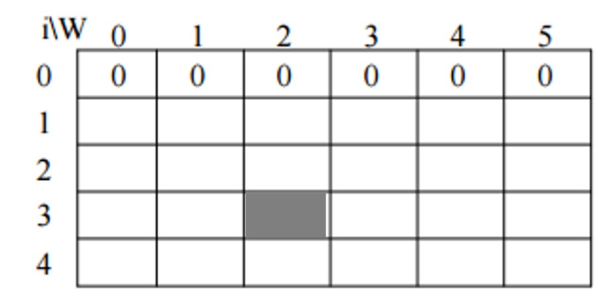

* 1. (10 points) What is the subproblem of the shaded cell?
     1. “What is the most efficient way fill up a knapsack with a maximum weight of 2 using the first 3 items”

* 1. (50 points) Please solve this 0-1 Knapsack problem using the given table.
     1. A table with numbers and text

        Description automatically generated

* 1. (20 points) Please show what items should be placed in the knapsack to maximize the benefit.
     1. Starting at that maximized answer (7, bottom right corner), we can traverse this using the properties of the items.
     2. Since (5, 4) = 7 is different than (5, 3) = 6, we know that we use Item 4.
        1. Weight is now: 5 – 3 = 2
     3. Since (2, 3) = (2, 2) = 3, we do not use Item 3.
     4. Since (2, 2) = (2, 1) = 3, we do not use Item 3.
     5. Since (2, 1) =3 is different than (2, 0) = 0, we use Item 1.
        1. Weight is now: 2 – 2 = 0
     6. In total, we used Item’s 4 and 1.